10 Linux Commands
- systemctl is-enabled Jenkins:
Checks whether Jenkins is configured to start automatically at boot.

- systemctl list-units --type=service --state=failed
Lists services that have failed.
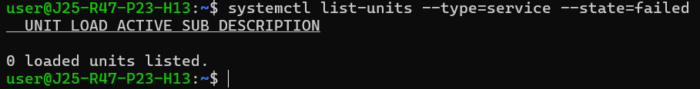

- journalctl -u jenkins --disk-usage
Shows how much disk space the systemd journal logs use.

- sudo lsof -i :8080
Identifies processes using port 8080, if lsof is installed.
- ip neigh
Shows the system's IP-to-MAC address neighbor table.
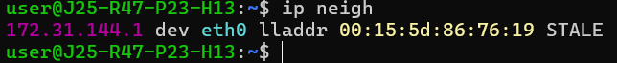

- sudo lsof /var/log/syslog
Shows which processes have files open.
- timeout 10s ping 8.8.8.8
Stops a command if it runs longer than a specified duration.
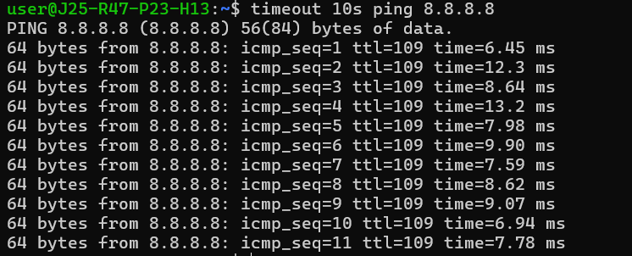
- watch -n 2 free -h
Repeats a command at regular intervals to monitor changes.
- ss -s
Displays network sockets and listening ports.
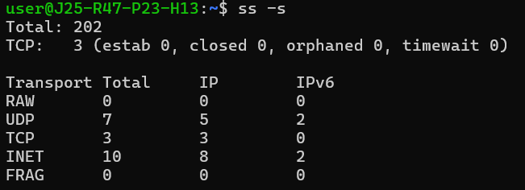
- echo "hello linux" \| tr '[:lower:]' '[:upper:]'
Translates or removes characters in text.

